Sarah Gallant
February 22, 1950 10:38 AM Cincinnati, Ohio
Sun in Pisces 11th
Venus in Aquarius (conjunct MC)
Moon in Taurus 12th
Taurus Rising
Born Aquarius meta Goddess, changing to Capricorn 1974

I am a Brilliant Morning Star Goddess claiming my fullest engagement with the Magical potential that lives in the Between, where I learn to live in the present moment, to dance with and in Paradox, and to ultimately embrace the paradoxical as the creative loom upon which universal forces are woven.
The Meta Goddesses that guide me on the Path to full goddess awakening are the Aquarius and Capricorn Goddesses who assist me in honoring the ancient while creating anew…and who are teaching me the TRUE meaning of Sacrifice (born with Aquarius Overtone, changing to Capricorn in 1974)
Born after heliacal rise just one day after Venus’s stationing stillness, and just before her first ecstatic reunion with the Moon, the path before me is inscribed with the words “THE STILLNESS THAT IS THE DANCING”
The (Present, Future) Goddess I am here to embody in all of her glory is the Visionary Aquarius Goddess who is radiant with the compassionate and devoted Heart of a Pisces Sun conjoined with Vesta.
Meta Goddess Aquarius is supporting me in expanding my consciousness, honoring uniqueness, and achieving a Cosmic Perspective. Meta Goddess Capricorn asks me if I am willing to share my unique and visionary perspective with Love and in Service for the good of the Community and generations to come. I answer yes – it would be an honor and so fulfilling to contribute in this way.!! (and then Meta Goddess Capricorn whispers discreetly that just maybe I could be a bit less eccentric (tho still a free electron) too, discerning the times when so doing would serve the highest purpose without sacrificing personal integrity) and Capricorn also asks for grounding the vision alive with the guiding light of the Circle of Grandmothers. ) …
(believing in self and that I have something of value to offer and saying yes with excitement. Trust, clarity and confidence as well as discernment in what I say yes to is part of my learning curve…and so stepping from self into Self is necessary – although not negating either place or perspective– integrating as personal and transpersonal meet and merge)
My Aquarius Goddess is fully engaged in the Mystery School training of Taurus where I have also had prior training (Moon is in Taurus). My ancient Taurus Soul remembers when the Matriarchy gloriously reigned and Goddess ruled. And she remembers when the Matriarchy was forcibly uprooted and it was no longer safe to live in fully embodied Aliveness. She remembers watching the beautiful Tree of Life being desecrated, branches floating down the river of her own (and collective) tears as she attempted to swim upstream. Scrambling for higher ground, she gazed from a mountain top and could see where the River met the Ocean…and here she felt as though she actually BECAME the Ocean…as her Heart drifted away with the branches of the Mother Tree.
(It became important to find footing on the land once again…without losing the Oceanic…and to do so with more personal objectivity and more passionate dispassion than ever before; to feel the Joy of Fully embodied Aliveness in creating “Heaven on Earth” )
Having endured, I am ENJOYING. Having survived, I am THRIVING, Blooming where planted in this once seeming alien society, having fun co-creating a beautiful New Earth garden with others, as I continue to root and reach, reach and root…planting seeds of Hope and Love to honor the One Heart that beats for us all..
I am reclaiming the gifts of intimacy, pleasure, beauty for beauty’s sake and re-embodying the Aliveness of Ecstatic Life Force as an Earthly and Celestial right. Black Moon Lilith in Taurus assists my ‘this lifetime’ Taurus Mystery School passage with the desire, grit and courage to root again in Sacred and Higher ground, to grow, flow, and flourish, forging my own unique path to wholeness...the Rainbow Way
In Service to Self, In Service to Spirit, A Detached Merge-Master – Personal, Transpersonal – Involution, Evolution, Feeling younger while growing older - Denim and Leather are Beautiful with Silk, Lace and Satin - Not Here, Not there – yet Everywhere – Beneficial Combinations – Recombining - At Center it is all One and the Same Timeless Time
I Root and Reach,
Reach and Root
Lovingly Embodied
My Life becomes a Prayer-Stick for Me and thus the World
(to this I aspire)
___________________________________________________________________________________
This above is what I submitted the first time that I took this class, The following are additions focusing primarily on outer planet transits that have been and continue to be life changing.
I’ll add that I feel a deep resonance with the Gemini cycle too and have been exploring this – I realized that I was conceived in a Venus Gemini Goddess Cycle when the Sun was also in Gemini. My Mom had a Gemini South Node and my Dad a Sun/Venus conjunction in Gemini. And in exploring the Gene Keys, I found connections there – more weaving and contemplating that adds depth and a more complete understanding for me. In retrospect the Gemini cycles have been incredibly significant too… most notably the last one in 2012. I wonder if others feel a resonance with the cycle they were conceived in if different from the one they were born in?
Gemini is also on the cusp of my second house where in the Placidus house system natal Uranus resides at 1 Cancer 02 RX. At age 15 Uranus went direct by secondary progression and the once model child became a rebel…now fast forward to 1996
Venus Themes and the Outer Planets – Activations through transits – 1996-2020 and beyond
I do not have the square or conjunction or opposition to Venus from the outer planets though they are tied by other aspects. With natal Neptune on the SN and Sun in Pisces and trine 10th house planets, I feel she is a big influencer. Pluto is in a wide opposition (13 degrees) to Venus, so I consider it because of the T square configuration with Moon, ASC, Pluto, Jupiter and Mercury that Venus feels to be drawn into…
Beginning in 1995, Uranus began its transit over my MC and natal Venus. In the spring of that year I had an awakening experience. It was as if lightning struck my head, dramatically opening me to new ways of seeing/perceiving. The theme of the experience was the purpose of suffering. I suddenly understood that perception was key to life experience, that we create our own hells and heavens…A moment of Grace
After many years of seeking, the quick as a flash experience changed my life forever. There was no turning back. I had been living as a victim, feeling the oppression and the acute anguish of feeling different and separate – never wishing to conform, yet feeling always on the sidelines of life. I was empowered through this awakening to live life in a totally different way, taking risks, utilizing voice via advocacy work and finding new ways to share what I hoped were empowering messages with others at the mental health recovery organization I worked for at the time. I felt a sense of purpose, a mission
Neptune was soon to follow Uranus, transiting conjunct MC and Venus late 1996. 1997. Creativity had always been a healing balm for me and I witnessed the abundant creativity present in the community at the Recovery Initiative. I began an artist collaborative for “mental health consumers” that was dedicated to the art of healing, joining with others to support our art and to open new venues and vistas for sharing and opportunity that gave voice to individual journeys and their collective significance.
The community at large (in our city) was overall very receptive and supportive, and joined with us offering venues, teachers, practical assistance and we found community artists outside the Recovery Initiative who had experienced similar feelings of marginalization and who joined their voices with ours. These years were simultaneously difficult and rewarding, I learned so much, made mistakes and experienced victories and felt as though I had something of value to offer...
In 1998 (during my 6th personal Venus return – age 48) when Neptune was conjunct natal Venus I painted a painting that is still revealing itself to me and actually has the symbol of Venus on it…It was painted from a lens of standing in the present, looking back and capturing the journey thus far, and looking into the future - its called Alchemy 1: Awakening. There are interesting connections I’ve discovered more recently to the Gene Keys and Human design too…that I hope to write about in detail at another time if only for myself…
The poem in the disc reads:
When Darkness Falls and Time Stands Still
And Forward Motion is Denied
Souls Trapped and Calling from an Abyss Below
Are Crying Bitter Tears into the night
Unheard
Wingless Angels crawl
From separate hells
Shrouded in disparaging shadows
And tormenting words
Then with paint and brush, with pen in hand
Join together to create their collective ascent
Sowing seeds of hope as the dawn arrives
Illuminating spiral stairways into the
Light

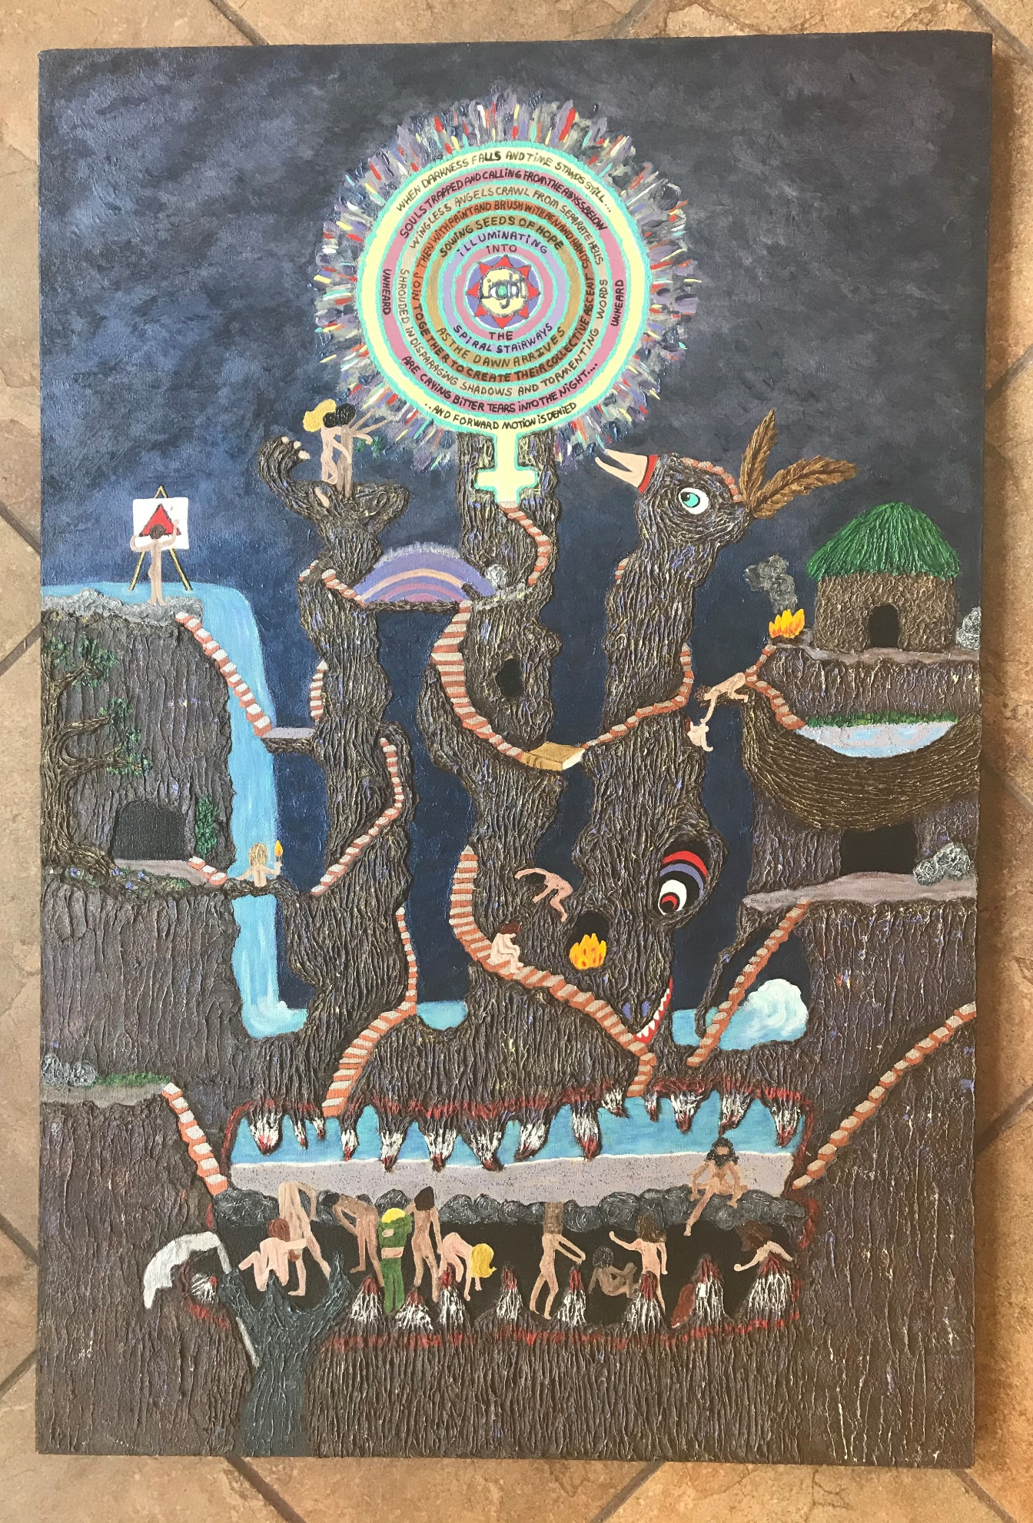

In 2007 right after my 7th personal Venus Return, when Venus rose as a morning star in Leo and was conjunct the Moon at the first gate (also conj. my natal Pluto) I painted Hope is Alive: Everybody is a Star. Transiting Neptune was then conjunct natal Jupiter in Aquarius and transiting Saturn in Leo conjunct natal Pluto as well. Here a figure stands on the earth opening into new partially defined vistas and here rainbows are bridging either side of her path opening from an 8 pointed star……A Sunflower Sun blossoms in the sky…and a Raven is flying overhead…This painting seems to zero in on the disc at the Center of the Venus Symbol in Alchemy 1- and expands it…
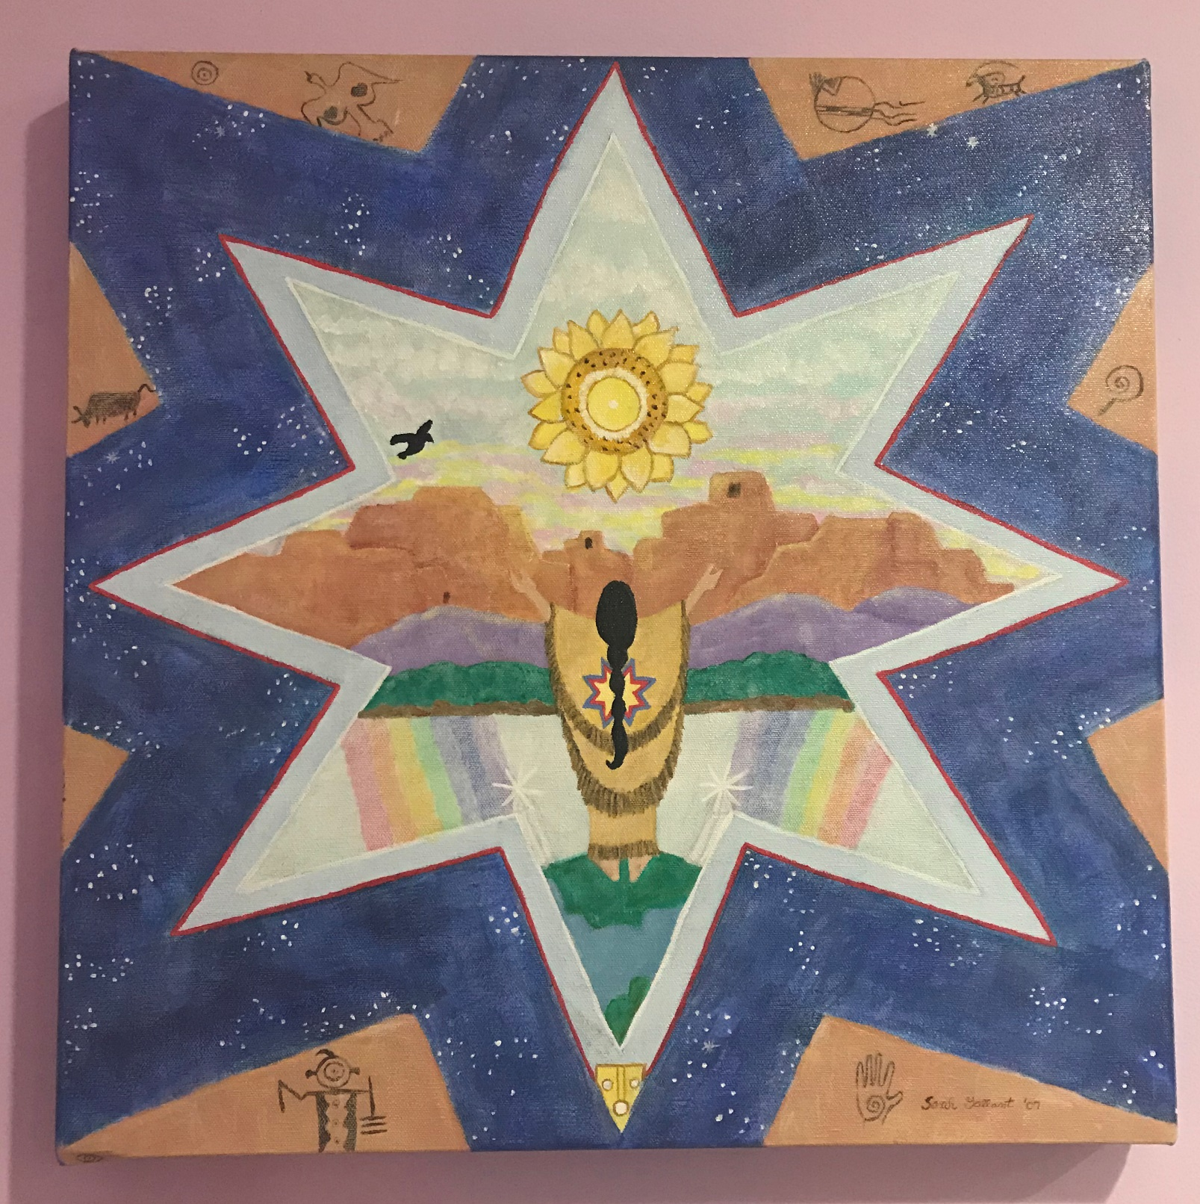

Uranus and Neptune have continued to move through my chart over Mercury, Jupiter, Sun, North Node, Some beautiful and opening magical deep experiences during those years that I cherish…
More recently as Uranus began transiting the Moon (7 Taurus 06) thus squaring Venus. much more was and is being revealed about unhelpful emotional habit patterns, reactions and circular thought patterns –Ive become more aware of another layer of dynamics here and am finding I’m moving more quickly through and my intention is with deeper understanding that creates more grace and ease.
Currently, Saturn is conjunct my Natal Venus and the natal MC. I am feeling called to restructure, reorder, re-story. focus and commit, and also to reflect on the journey thus far with gratitude for how far that I’ve come and for all assistance along the way. A message I’ve gotten is to “trust seeds already planted” , to harvest what is of value from the journey thus far and to creatively open into the new and to let go of what no longer serves that progression of the spiral…
On Winter Solstice 2021, Saturn and Jupiter just into Aquarius will conjoin my natal Venus and MC. Pessimism and optimism have been an interesting dance for me – I can swing either way depending. Yet going beyond those dual vibrations what I feel called to in the coming months is to ever more consciously tread the middle way of balance in all things…and to experience expansion and contraction as two valuable and complimentary aspects of flow…to be expansive and grounded/realistic, to become the flow while fully embodied, …to lose forever the self-criticism and feelings of inadequacy or at the very least be able to witness anything remaining residue with love and compassion and not allow them to limit me which can be so crippling –
And then there is Pluto, in the conjunction zone now of MC and Natal Venus…
Pluto will be in this Zone for a long time. I am both excited and a bit fearful wondering what this passage will bring…for the world and for me. (as I believe most of us may be now) My desire is to embrace the beauty and power of not knowing, stepping into this time joyfully being the very best that I can be, fully present and open to Destiny’s calling, and anticipating rainbows – I take the leap!
To embrace this magical opportunity for much needed personal/collective change and to purposefully participate with love, compassion, and passion is my intention. I’m ready and willing.
I feel as though, throughout life, society at large has moved to meet me, and I’ve moved to meet it. Kind of like the precession of the equinoxes meets the passage of linear time. Soul to Spirit. I’ve senses of this within the Aquarius/Capricorn coupling of the Meta Goddesses.
In 2012 during the last Gemini Goddess Cycle I left the Recovery Center and all work in that area where Id been since 1995 working as a peer. After returning from a leave of absence during which I interestingly went to study the Aura Soma color care system with a dear Rainbow Goddess friend, I felt called to OFFICIALLY expand my definition beyond labels and impositions (as I encouraged others to do while working there) and move out into the larger flow. This was shortly after my second Saturn return.
2012 was an incredibly magical year with a Rainbow theme. The lovely quote “May your Life be like a Wildflower, blooming Freely in the beauty and Joy of Each Day” became a mantra. My story now is much different than where it began. And the new story I’m writing will eliminate all unhelpful residue from years and ages past - -Hooray! I love the sound of it!! So now I just gotta do it! What a Rainbow Ride!!

